**Recommendation system (NRS)**

Description:

NRS system shows the desired recommendation results as per required by the user.

Scope:

92.2% accuracy is maintained in the system to satisfy the user recommendation needs.

Mission Statement:

User will only be able to see those Movies, Web-series, Serials & contents which are best of his interests. There will be less data consumption that user won’t have to spend a lot of data on the searching of desired contents. It won’t take long to show the desired results as the recommendation system is accurate enough to generate the desired interest list for the user.

Mission Objectives:

1. Desired recommendation list
2. Less Data Usage
3. More Provident
4. Accuracy & Reliability

Entities & Attributes:

|  |  |
| --- | --- |
| Contents | Id,Name, Year ,Production ,Rating,Genere_id,Rating |
| Genere | Type, Genere id |
| Con_Movies | Id, C_id,Duration |
| Con_Serial | Id, C_Id,season ,Episodes |
| Con_WS | Id,C_id,Episodes |
| User | Id, Name -> F. Name, L .Name, Date of Birth, Gender, Country/Region,  Payment Info, Address, Postal Code, Number ,Status |
| Payment | Name -> F. Name ,L. Name, Card No, Balance Expire date ,Cvc, Card Type, |

ERD:

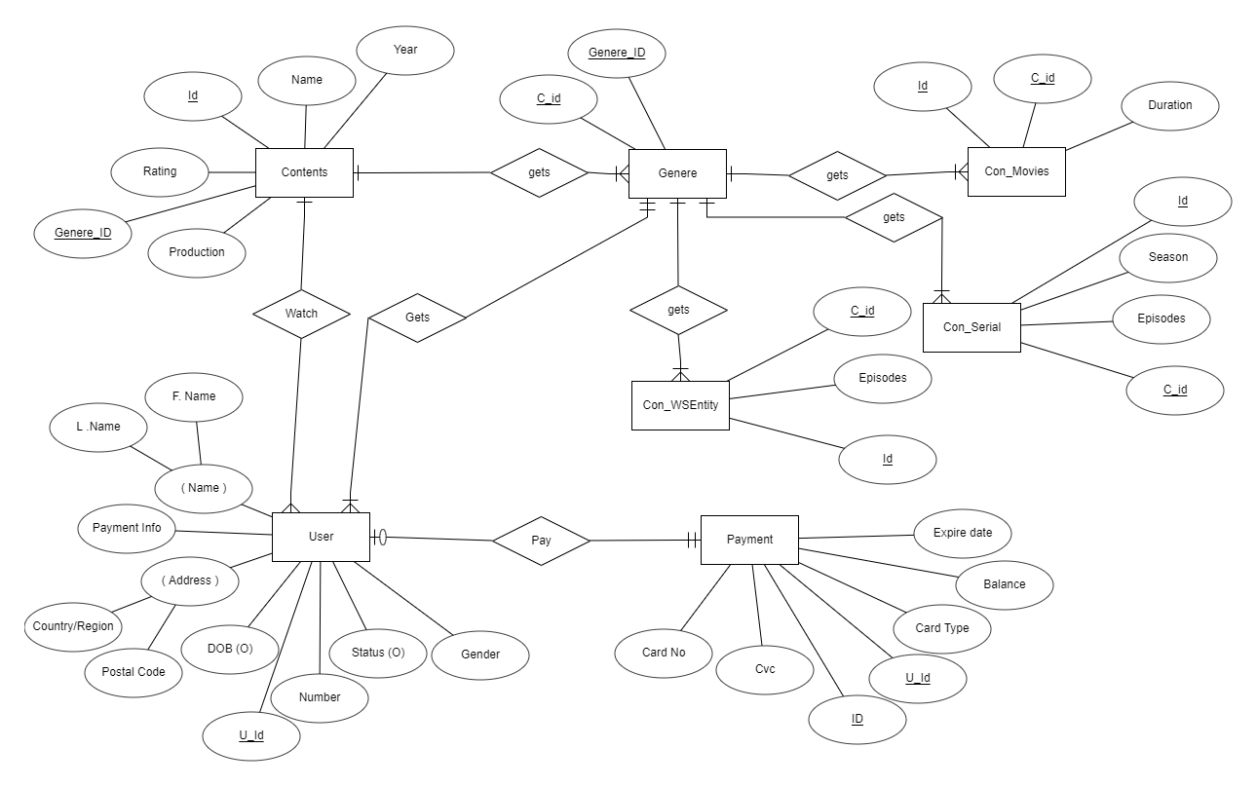

Relational Model